Declarative 3D Use Case for Public Outreach:

Web3D Timeline using X3D, X3DOM Scenes

Anita Havele Don Brutzman
anita.havele@web3d.org brutzman@nps.edu
Web3D Consortium Naval Postgraduate School
California, USA Monterey, California, USA

Abstract
Declarative 3D development efforts need to include a use case for public outreach models that serve as both good demos and good exemplars for authors. A Web3D Timeline scene has been constructed using X3D Prototypes. Adaptation of this scene is also explored using an X3DOM approach. This use case illustrates declarative 3D functionality.
Categories and Subject Descriptors
I.3.6 [Methodology and Techniques]: Standards| Languages; I.3.7 [Computer Graphics]: Three-Dimensional Graphics and Realism|Virtual Reality.
Keywords
X3D Prototypes, X3DOM, Web3D, Declarative 3D.

Motivation: Meaningful Exemplars
Given many recent developments in declarative 3D for the HTML environment, it is important to have good examples that show how 3D graphics can work on the Web. This is an important use case for the Declarative 3D Community Group that can help illustrate important rendering capabilities while comparing and contrasting the strengths and tradeoffs of different technical approaches. The objective of this work is to first make an interesting public- outreach scene using X3D prototypes, showing the

strengths and weaknesses associated with modularity and implementation interoperability. The scene is then reconstructed using X3DOM, Javascript and HTML as a way to compare various Declarative 3D and Imperative 3D approaches. An X3D to X3DCOM Stylesheet has also been developed to automate such conversions. We hope to identify several advantages and disadvantages. A well-defined use case for Declarative 3D is the result, with multiple possibilities for group feedback and further improvements.

X3D Prototype-based Design
X3D Prototypes provide a way for X3D authors to define and create customized new nodes that can be repeated in the X3D scene graph. X3D Prototypes (sometimes called Protos) are first defined inside an X3D Scene node. Prototypes have a special structure that begins with a ProtoDeclare initial declaration of its name, followed by a ProtoInterface that defines node fields. The X3D content of this template is then implemented inside the ProtoBody element. Field parameters matching the ProtoInterface definitions are connected via IS/connect statements within the proto body.
Prototype design is preferred if similar initialization values and repeated rendering results are needed, as in this Web3D Timeline scene. ProtoInstance allows repeated reuse of the design pattern used to define each demonstration image. Prototypes are a powerful technique for extending the capabilities of X3D. Few computing languages provide authors with the capability to extend the core vocabulary of the language itself. Whether such capabilities are essential for Declarative 3D remains to be seen. Figure 1 shows this fundamental design pattern.
<X3D version='3.0'>
<Scene>
<!-- Prototype template definition -->
<ProtoDeclaration name="MyNewNode">
<ProtoInterface>
<field name="index" value="0" accessType="inputOutput" type=”SFInt32” />
</ProtoInterface>
<ProtoBody>
<!-- content implementation here -->
</ProtoBody>
</ProtoDeclaration>
<!-- Prototype instance creation -->
<ProtoInstance>
<fieldValue name="index" value="1" />
</ProtoInstance>
</Scene>
</X3D>

Figure 1. Prototype design pattern illustrated.

X3DOM Implementation
X3DOM allows authors to directly integrate X3D nodes within HTML DOM content in a way that permits corresponding sharing of ID namespaces and HTML-X3D script-event addressability. One well-supported goal is to enable consistent use of declarative XML-based X3D scenes within HTML5. A manual translation of the Web3D Timeline scene from X3D to X3DOM was performed that took a programmatic approach to converting slide contents into Javascript data structures, building similar X3D scene functionality.

Demonstrations: Web3D Timeline Scene using X3D Prototypes and X3DOM Programming
Figure 2 shows the original X3D scene created using X3D Prototypes that demonstrate the capabilities and extensibility of native X3D. Figure 3 shows a corresponding interactive scene using X3DOM.
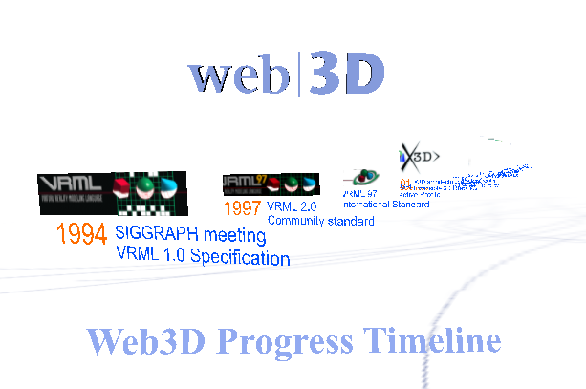
Figure 2. Web3dTimeline scene implemented using X3D prototypes.

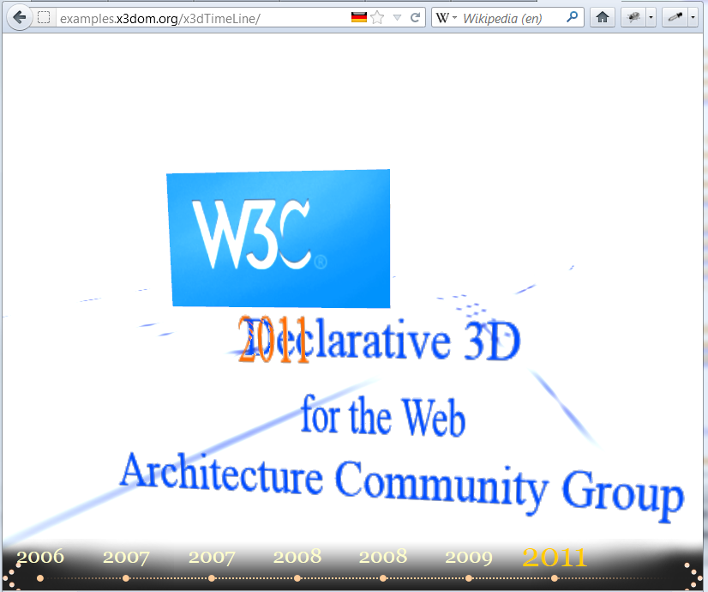
Figure 3. Similar Web3D Timeline scene implemented using X3DOM, Javascript, HTML

Conclusions and Recommendations

These scenes are excellent exemplars for demonstrating and comparing declarative 3D approaches using X3D and X3DOM.

In support of X3D interoperability with X3DOM, an XML stylesheet X3dToX3dom.xslt has been written and deployed that facilitates automatic conversion of native .x3d scenes into XHTML + X3DOM syntax. Further efforts to improve these assets and grow declarative 3D capabilities for the Web are ongoing.

6. Acknowledgements

Thanks to Nils Michaelis for the X3DOM translation.

Thanks to Johannes Behr, Yvonne Jung, and Andreas Aderhold for technical efforts on X3D and X3DOM.

7. References

Brutzman, Don and Daly, Leonard, Extensible 3D Graphics for Web Authors, Morgan Kaufmann, 2007. http://www.x3dgraphics.com

Declarative 3D Community Group, World Wide Web Consortium (W3C), http://www.w3.org/community/declarative3d
X3DOM, Fraunhofer IGD, http://www.x3dom.org

Web3D Outreach Online Examples
Web3D Timeline Scene, X3D
http://www.web3d.org/x3d/content/examples/Basic/Web3dOutreach then Web3dTimeline.x3d,
or directly at
http://www.web3d.org/x3d/content/examples/Basic/Web3dOutreach/Web3dTimeline.x3d

Web3D Timeline Scene, X3DOM
http://examples.x3dom.org/x3dTimeLine

X3D Prototype Tutorials
http://doc.instantreality.org/tutorial/creating-custom-nodes-with-prototypes
http://x3dgraphics.com/slidesets/X3dForWebAuthors/Chapter14-Prototypes.pdf
X3D to X3DOM Stylesheet
http://www.web3d.org/x3d/stylesheets/ X3dToX3dom.xslt

X3D Resources

http://www.web3d.org/x3d/content/examples/ X3dResources.html

